How to migrate EC2 from one region to another region
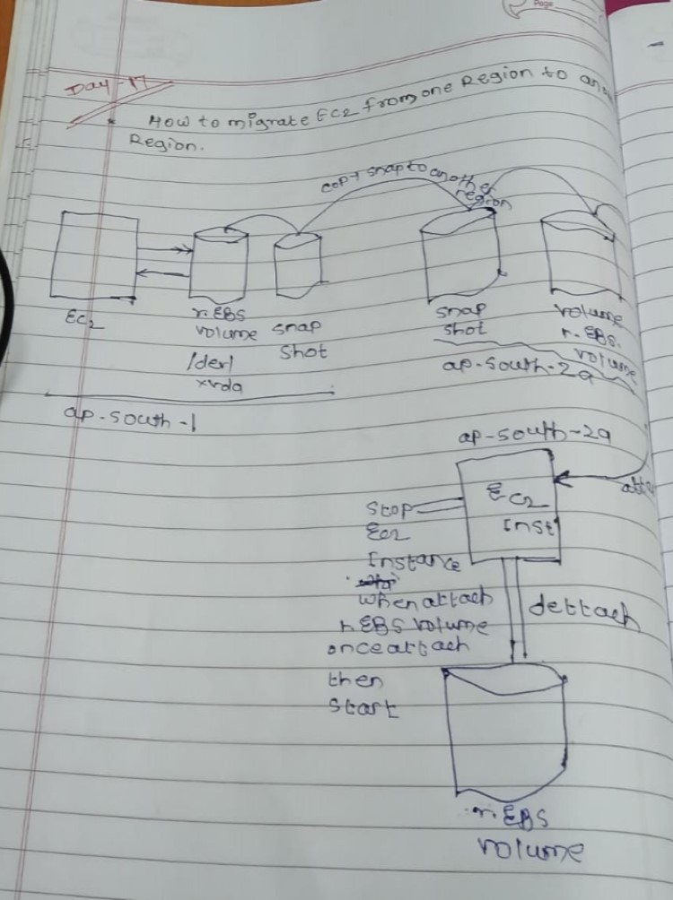

- Create one instance in ap-sounth-1 region
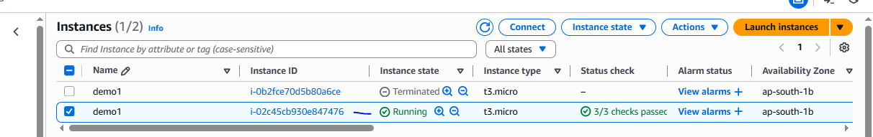
Once instance created please install the docker using below commands
sudo yum update -y
sudo yum install docker -y
sudo systemctl start docker
sudo systemctl enable docker
sudo usermod -aG docker ec2-user
docker --version
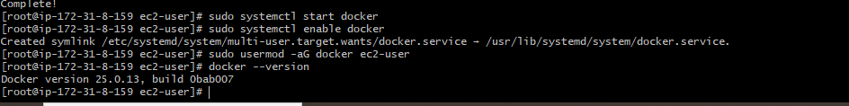

Create a snapshot of R. ebs volume
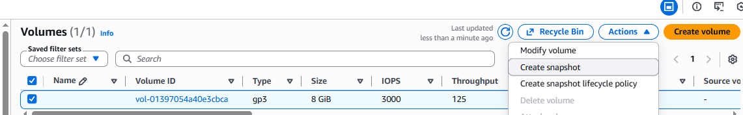
Snapshot has been created
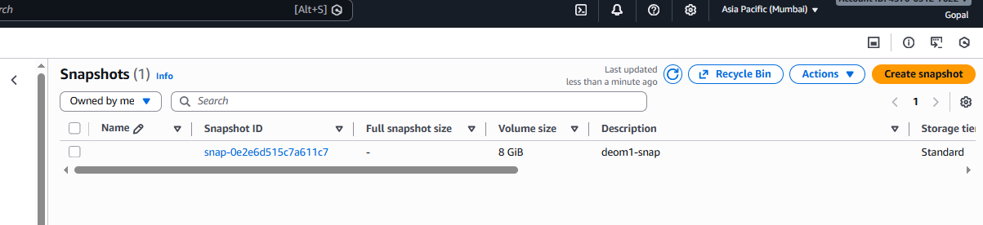

Copy the snapshot to another region
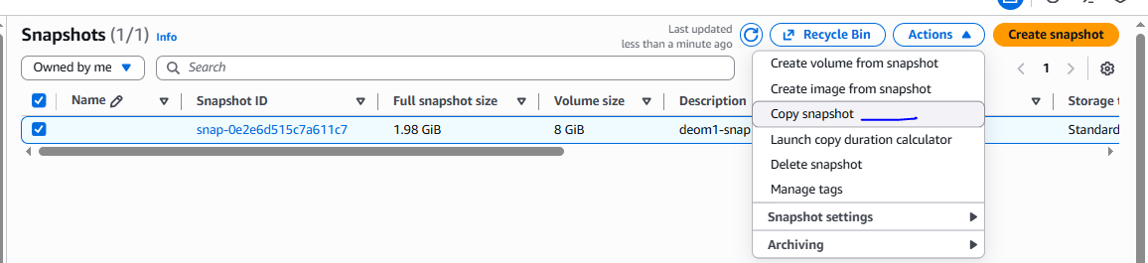

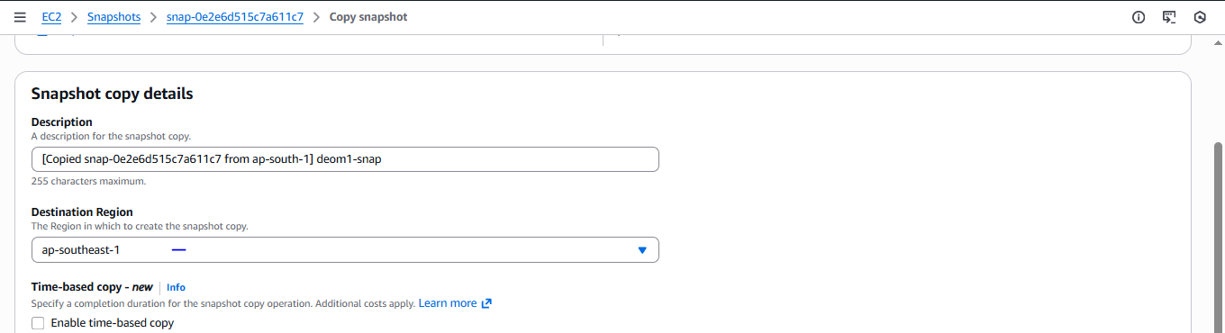

Snapshot copied to another region

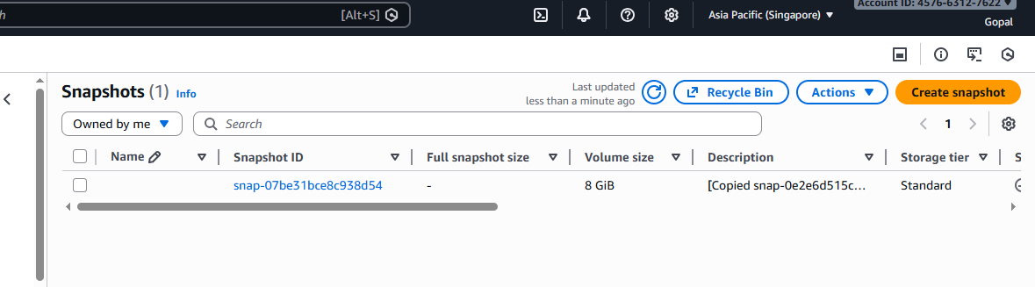
From snapshot to create a volume from snapshot in same region
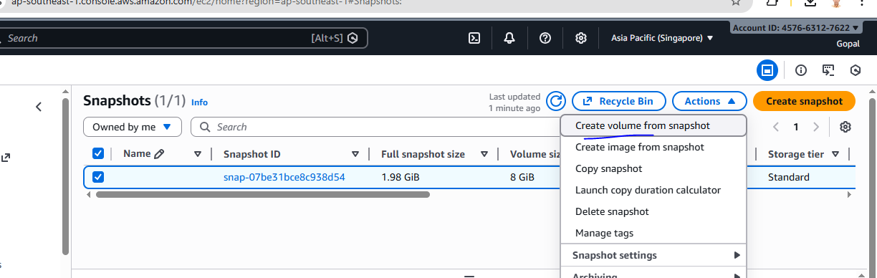
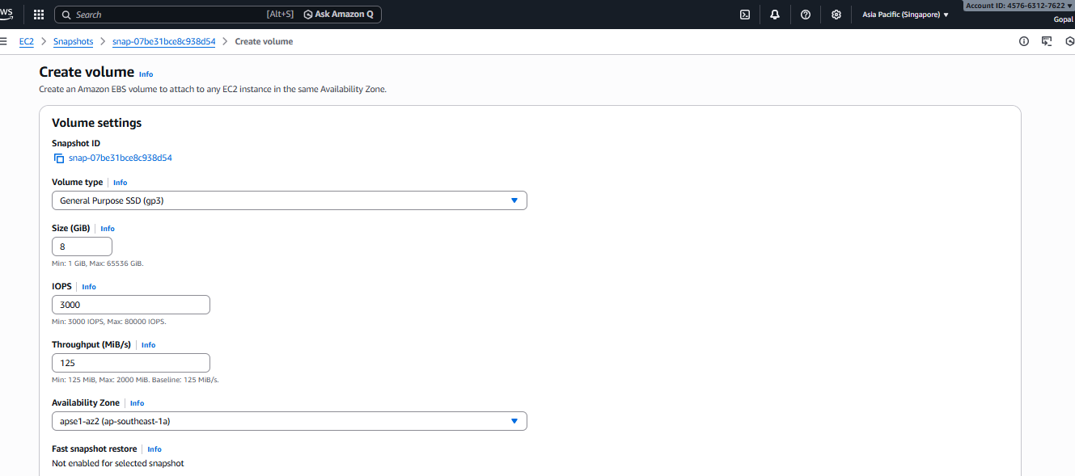

Volume created in another region
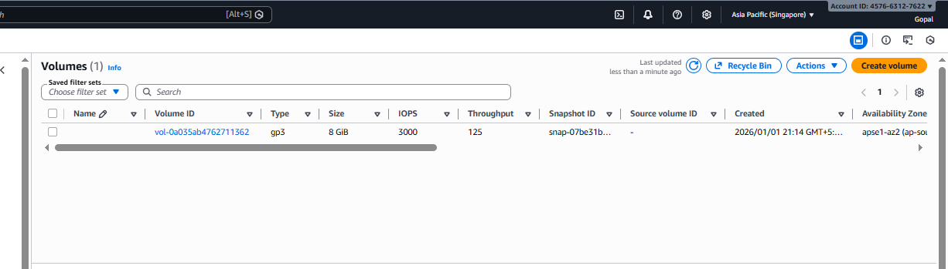

EC2 instance created in another region and stop to remove the existing volume
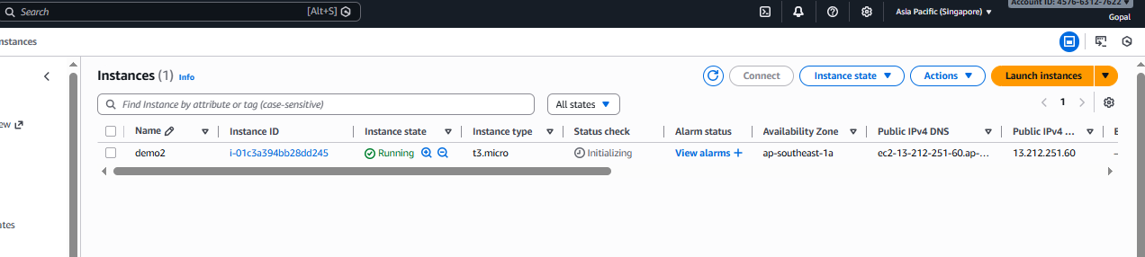
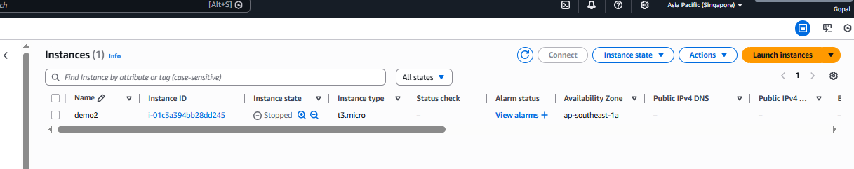

Detach R. EBS volume to attach the volume which from creating the snapshot
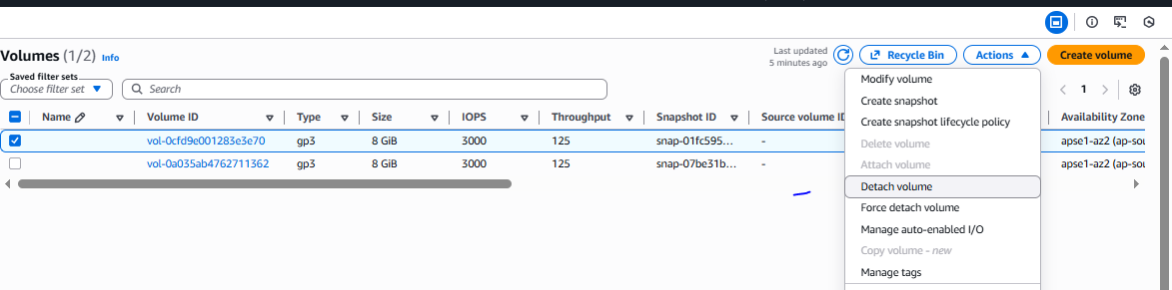

Attached the snapshot volume to instance
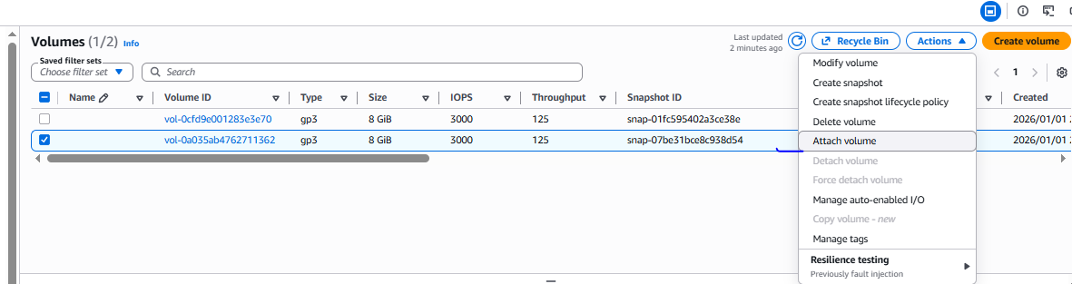

Once attached please start the instance
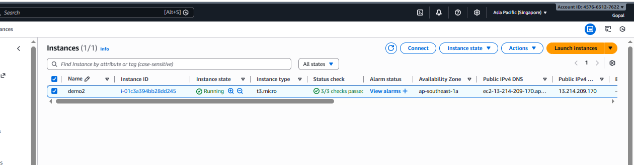

Verified docker present on other instace (which is created other region)
